**Algorithm for array Insertion (Adding an element in an array)**

1. First get the element to be inserted, **say x**
2. Then get the position at which this element is to be inserted, say **pos**
3. Then shift the array elements from this position to one position forward, and do this for all the other elements **next to pos**.
4. Insert the element **x** now at the position **pos,** as this is now empty.
5. Finally increment the size of array by one.

Let's take an array of 5 integers.

1, 20, 5, 78, 30.

If we need to insert an element 100 at position 2, the execution will be,

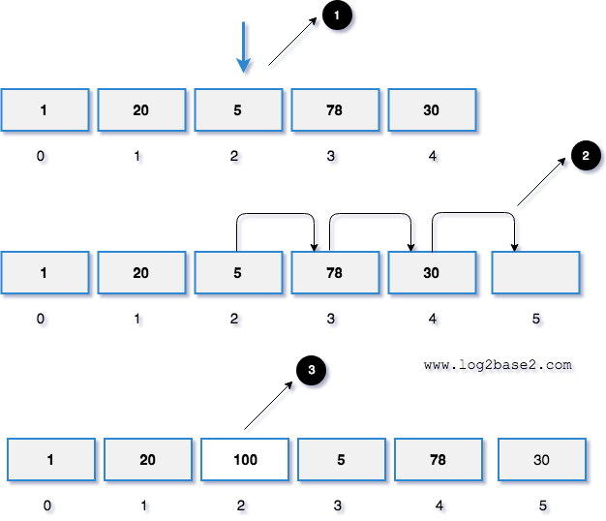



**Algorithm for array Deletion (Removing an element from array)**

1. Move to the specified location which you want to remove in given array.
2. Copy the next element to the current element of array. Which is you need to perform array[i] = array[i + 1].
3. Repeat above steps till last element of array.
4. Finally decrement the size of array by one.

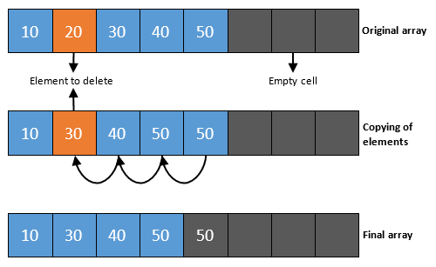

Step by step descriptive logic to remove element from array.

**Breakout Room Exercises (time 10 minutes)**

Assume you got the following data elements stored in an array structure:

34,56,12,78,90,45,67,20

* 1. Demonstrate how to delete element 90 (depict with diagram)
  2. Write a C++ program that search for value 90 and then delete it

Assume you got the following data elements stored in an array structure:

34,56,12,78,90,45,67,20

* 1. Demonstrate how to insert element 40 between element 90 and element 45 (depict with diagram)
  2. Write a C++ program that search for value 90 and then insert value 40 at that index location